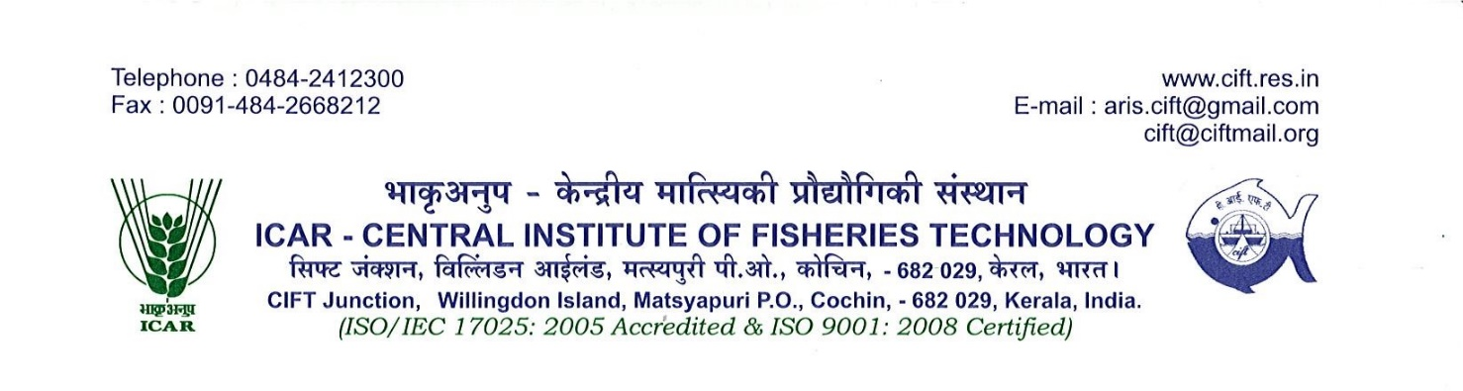Date: 8th July, 2017

**PRESS BRIEF**

**A&N administration holds ‘Stakeholders Meet’to promote fisheries in Islands**

**A Stakeholders Meet** on ***Development of Tuna Fisheries in Andaman and Nicobar Islands*** was held at Kochi based ICAR-Central Institute of Fisheries Technology today i.e. on 8th July, 2017 on the behest of Andaman and Nicobar Administration. The event was organized by Andaman& Nicobar Administration and ICAR-Central Island Agricultural Research Institute, Port Blair in association with ICAR-Central Institute of Fisheries Technology (CIFT), Kochi and ICAR- Central Marine Fisheries Research Institute, Kochi.

Presiding over the programme, Shri Anindo Mazumdar, IAS, Chief Secretary, A&N Administration highlighted the importance of fishery for the economic growth of Andaman & Nicobar Islands. He said that A&N islands being endowed with unexploited abundant marine fishery resources, is a virgin place for the Investors and emerging entrepreneurs to come forward to take advantage of tuna and other fishery resources of the Islands. Port Blair is now well connected with 16 flights every day with main land and steps have already been initiated for launching of high speed internet connectivity in the Islands, he said. During his deliberation, he assured the participants that A&N Administration will provide single window clearance for interested entreprenuers and mentioned that the A&N administration will come out with a comprehensive fisheries policy for the livelihood development in fishery sector and expressed his interest in developing a fishery industrial park to facilitate tuna fisheries development in the Islands.

At the outset, Shri Ramesh Verma, IAS, Secretary (Fishery), A&N Administration in his welcome address mentioned about the umpteen opportunities for large scale investments in fisheries sector in Andaman and Nicobar Islands and ensured all possible support to the entreprenuers for start-up business in the Islands. Dr S Dam Roy, Director, ICAR-Central Island Agricultural Research Institute, Port Blair in his presentation gave overall scenario of fisheries resource available in the Islands and in particular about the under exploited straddling tuna resources. He emphasized upon increasing fishing capacity, setting up of seafood processing facilities and encouraging direct exporting for the development of the sector.He also mentioned in detail about the activities taken up by the department of fisheries, Andaman and Nicobar Islands for fisheries development.

**Cont…….**

Dr. Mohan Joseph Modayil, Former Memebr, ASRB and Director, ICAR- Central Marine Fisheries Research Institute, Kochi enlightened on the outlook required for tuna fisheries development in the Islands in which context he pointed out the need for fisheries resource stock assessment and required infrastructure development in Andaman and Nicobar Islands.He also stressed on the requirement for single window clearance for the interested entrepreneurs and the need for deploying >20 OAL fishing fleets to exploit the fisheries resources of the Islands.

Congratulating the efforts of Andaman and Nicobar Administration for conducting the stakeholders meet in the fisheries capital of India; Dr. C. N. Ravishankar, Director, ICAR-Central Institute of Fisheries Technology, Kochi highlighted the harvest and post-harvest fishery technologies developed by the institute, which can be a path finder for this kind of initiative taken by A&N Administration.

The inaugural function was followed by an interactive session, which was attended by more than 130 stakeholders comprising of investors, fish-processors, entrepreneurs, progressive fishermen from different coastal states namely Gujrat, Tamil Nadu, Andhra Pradesh, Karnataka, Kerala etc. along with officials and scientists from A&N Administration, line departments of Kerala, MPEDA, MATSYAFED, ANIIDCO, NABARD, NIPHAT, ICAR-CIFT and ICAR-CMFRI. The Stakeholders meet wascame to an end with vote of thanks extended by Shri J Chandrashekar, Director of Fisheries, A&N Administration.

During the interactive session various concerns raised by the prospective investors related to administrative support and vessel management facilities. Issues related to resources availability like required amount of quality ice, water, power, berthing and repair facilities for vessels, bycatch processing facilities etc. were discussed in detail. Lastly, while summing up the deliberation, the Chief Secretary, A&N Administrationassured that all possible infrastructure will be developed in phased manner and urged the prospective investorsto extend all possible cooperation for the development of fisheries in the islands.

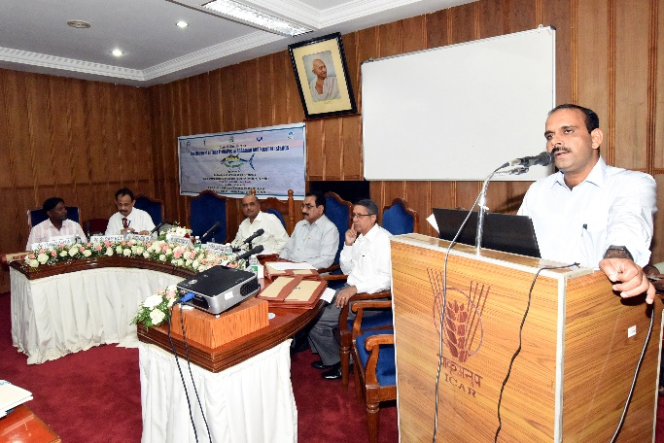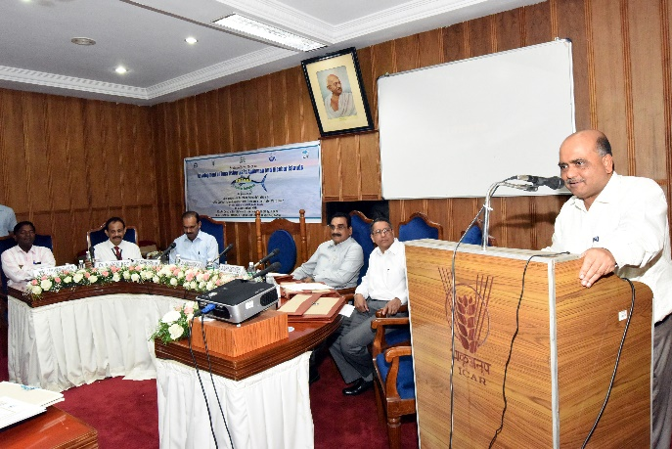

Presidential address by Shri Anindo Mazumdar Chief Secy, A&N

Shri Ramesh Verma, Secretary (Fy) A&N welcoming the delegates

**Cont…….**

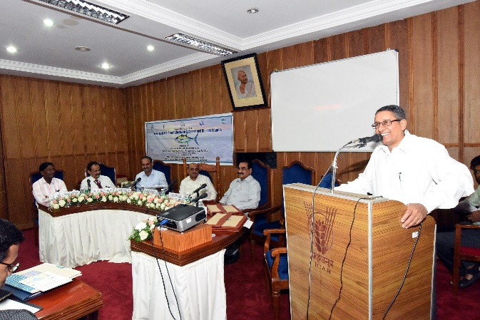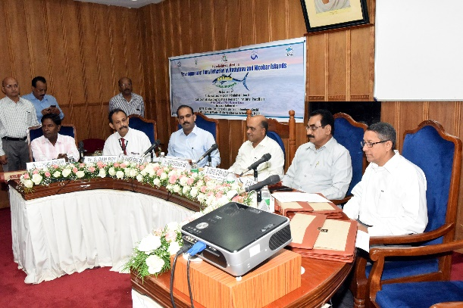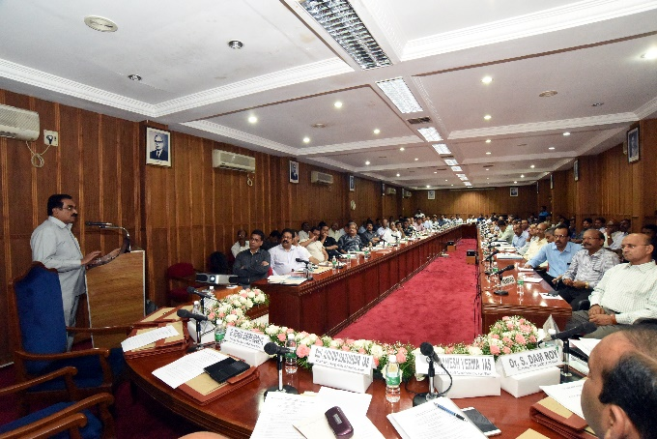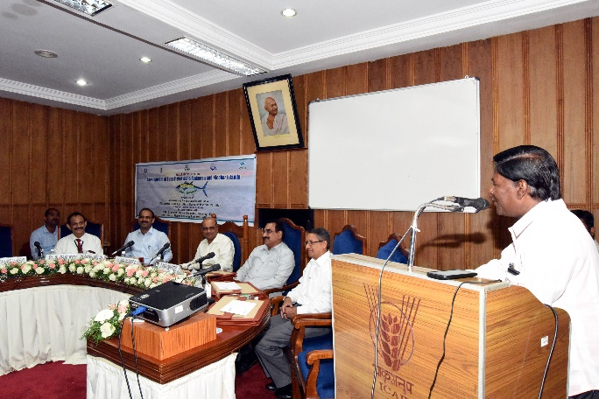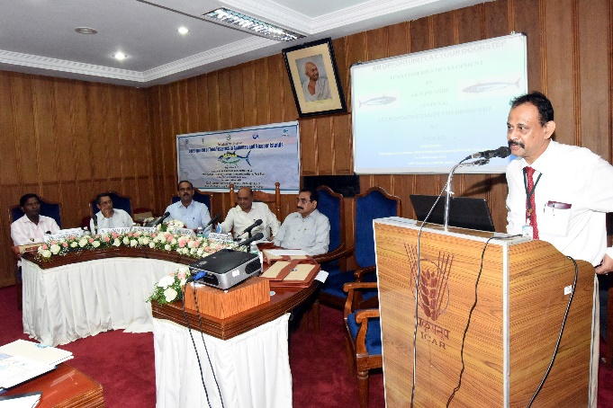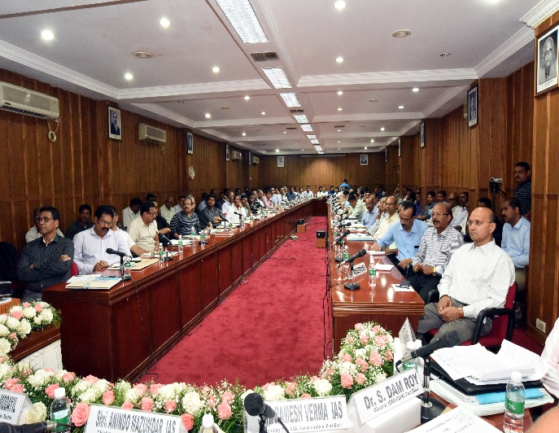

Interactive Session during the Stakeholders Meet in progress

Deliberation by Dr. C.N. Ravishankar, Director, ICAR-CIFT

Dr. S. Dam Roy, Director, ICAR-CIARI addressing the meet

Dr. M J. Modayil enlightening the audience

Director (Fishery), A&N Admn. extending vote of thanks